Tyler Eck

410821337

03/01/2023

Introduction to Virtual Reality

Final Project Report

1. Introduction

National Dong Hwa University has the most beautiful campus in Taiwan filled with stunning views of the enormous Hualien mountains and gorgeous landscapes. However, for many years now, some of the main buildings, including the science buildings and humanities buildings, have been plagued with disgusting disease-carrying pigeons that leave their “droppings” everywhere. These fearless pigeons need to be stopped as they destroy NDHU’s chance of getting any recognition for having such a pristine and clean environment. Therefore, the game I propose for my final project is called NDHU Pigeon-Stop. The goal of the game is to stop any and all reproducing pigeons from terrorizing the beauty of these buildings. The playable avatar will encounter different types of pigeons and will have different methods to kill them.

It seems like a very difficult project to take on as there are many buildings in Dong Hwa and the idea of designing swarming pigeons with different abilities seem daunting. However, I will stick to one or two buildings in Dong Hwa making it a little less complex. Moreover, most of the resources that I will use will be from exported Unity packages.

1. Background

The game will be designed by using Unity 2021.3.11f1, the version that I have used for my previous projects. Unity is a cross-platform game engine developed by Unity Technologies and was used in our classes. With Unity Real-Time Development Platform, I can design this game to be implemented both as a 3D game with mouse and keyboard controls or even as a virtual reality game.

Another program that will be used is SketchUp 3D to make the NDHU buildings. I will not necessarily make the buildings from scratch, but instead use the science building that I built from our previous project and ask another classmate for another building. The main purpose of the building is design and has no real functionality. Therefore, I am treating it as a package that I can import into my project.

Although the idea wasn’t exactly gotten from any academic papers or commercial products, many popular Virtual Reality RPG games such as Blaston, Phantom: Covert Ops, and Superhot VR were used as inspirations for NDHU Pigeon Stop. Moreover, the Dino Hunt program that we made in class is a perfect example of how I can use what we learnt in class and extend off it to make a more unique and better game.

1. Method

NDHU Pigeon Stop is a basic game that I tried to design to implement all these concepts and techniques learnt in class. The overall structure of the project can be split into 3 parts:

1. Design of the environment
2. Design of the characters and pigeons
3. Functionality of the characters and pigeons

The design of the environment will be a basic 3D design to mimic NDHU’s environment, specifically the science buildings and humanities building. From the streets to the trees to the terrain, all of these will be designed and implemented by using both Unity and Sketchup 3D. As stated in the previous section, Sketchup 3D will be used to design the buildings as we did in our previous project. Moreover, these objects will just be exported to Unity to use as I want. I will use Unity to design the terrain and landscape by using all the techniques we learnt in class.

The design of the characters and pigeons will also not be done from scratch as it would take too much time to design. Therefore, I will use packages such as Standard Assets and Living Birds to import the main character with their 3rd person point of view camera and living birds for the main birds that will be used. Most of the bird packages are not free, but I will try to search through more thoroughly.

Lastly, the functionality of the characters and pigeons will be done in Unity. C# scripts will be implemented in order to effectively allow for proper interaction between these two rival characters. Weapons, each with their own size and sounds, will be chosen by the character to use in combat. Moreover, the different types of pigeons with different skill sets will also be shown clearly.

I have not started the actual project yet, but I have done the preliminary planning and I know the setup of how I will go about implementing it. It is also important to point out that because the class is centered around teaching Virtual Reality concepts, a big emphasis is placed on implementing these games with the VR headset. Unfortunately, I do not have a VR headset, nor do I have time to borrow the headsets from the lab to use in my development. Therefore, I will implement the game by using just the keyboard and mouse for now and if additional time is given and permission is granted, I will also try to extend the game to have a VR mode.

The basic schedule shown below is what I will follow to finish my project on time. I have two weeks left to finish which is more than enough time to build my project.

Schedule:

Week 1:

* Gather all packages to use and create the empty unity project
* Design terrain including the science building with streets, lamp posts, sidewalks, and trees.
* Populate the environment with three different kinds of birds (preferably pigeons)
* Create and place character with third person point of view into game

Week 2:

* Create functionality of the different birds each with own abilities.
* Create functionality of character including the different weapons they can use each with their own range of attack. This also includes the aiming and firing of the weapon to kill the birds.
* Create point system to count number of birds killed.
* (Optional) Create Humanities building environment and do the same game setup
* Finish report and game manual

1. Results

I achieved most of what I wanted to do with this project, but I found myself restricted due to the limiting number of free assets that I could import into my project. For instance, as stated above, I wanted to import an asset that included designed 3D avatars that I could use as prefabs in my project. However, when searching the asset store, I could not find any free ones. Moreover, not being able to find any free “pigeon” assets also made me reconsider changing the name of the entire project.

Although these were integral changes to the project, I found a way around it. The above problems were solved by using the Starter Assets: “ThirdPersonController” and using an “eagle” asset instead of a pigeon one respectively. Shown below is a simple list of all the assets that I imported and used in my project with a short description of how they were used. This gives more context into how I went about actually implementing the functions described in the “Method” section.

|  |  |
| --- | --- |
| **Assets:** | **What Used?** |
| AllSkyFree – Skybox | Used to make the “Cloudy NDHU Sky” Material that was used to decorate the sky |
| Background Car – Free | Used as simple background cars for environment decoration. |
| Brat | Used as simple background motorcycles (Could not find scooters) for environment decoration. |
| Egypt Pack - Eagle | Used prefab to make the main enemy birds that were used instead of pigeons |
| FREE bicycle pack | Used as simple background bicycles for environment decoration. |
| HD Low Poly Racking Car No. 1201 | Used as background cars for environment decoration |
| Sedan Car | Used as background cars for environment decoration |
| Modular Lowpoly Streets (Free) | Used to design the streets of NDHU with included lampposts and intersections. |
| Starter Assets 2018.4 | Used to decorate environment with trees, grass, and wind. (Even though it is deprecated) |
| Starter Assets – Third Person Character Controller | Used as prefab to make the main third person character |

1. Designing the environment

Most of these assets were used for design which was the longest and most tedious part. However, I believe that with the combination of my hard-working efforts and the above assets, I captured the essence of Dong Hwa’s campus, specifically around the science buildings. Shown below are some screenshots of the finished environment with some class-taught decoration methods applied including skybox, terrain, wind, and trees.

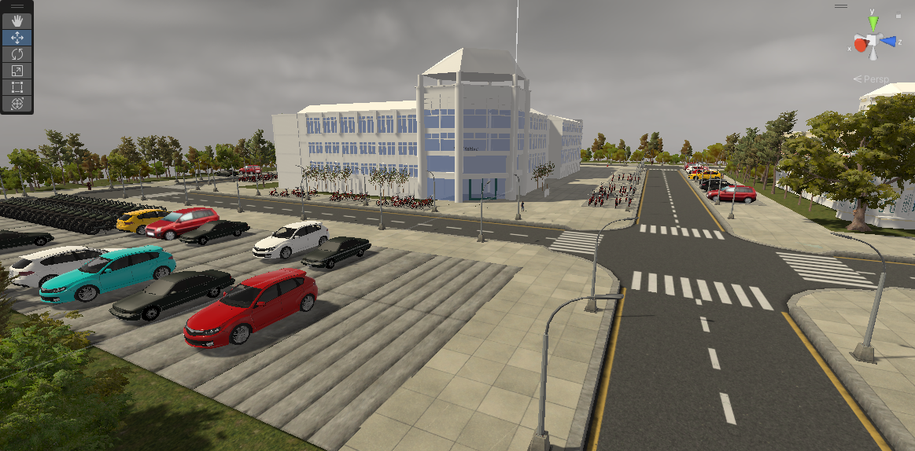

**Game Environment Picture #1**

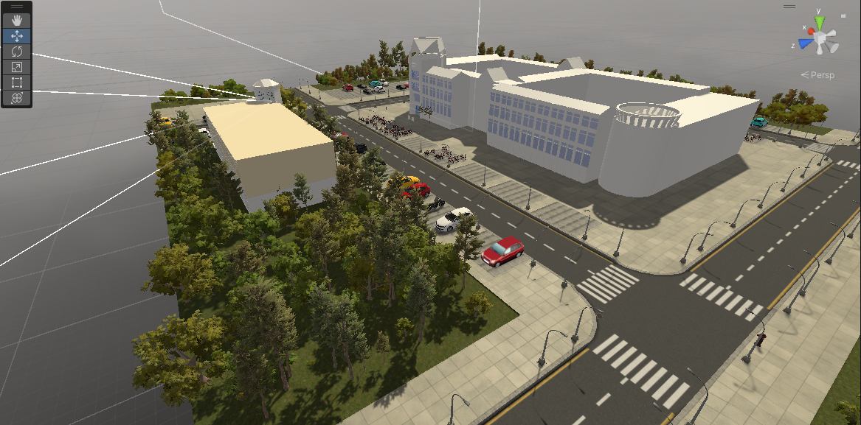

**Game Environment Picture #2**

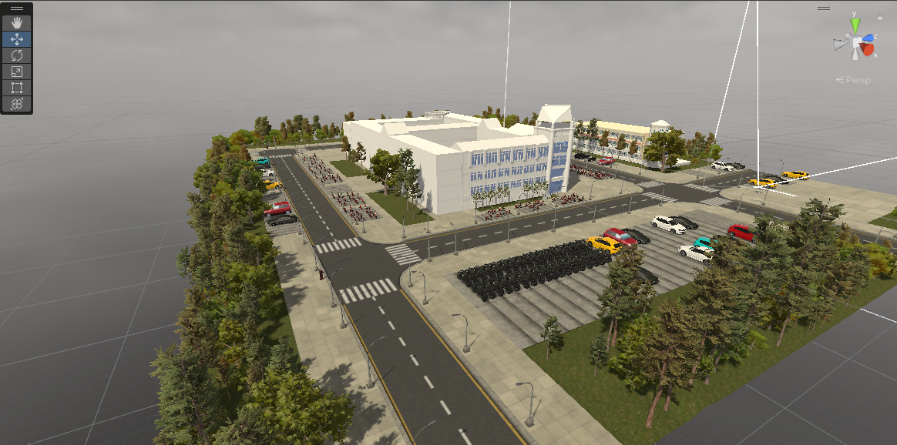

**Game Environment Picture #3**

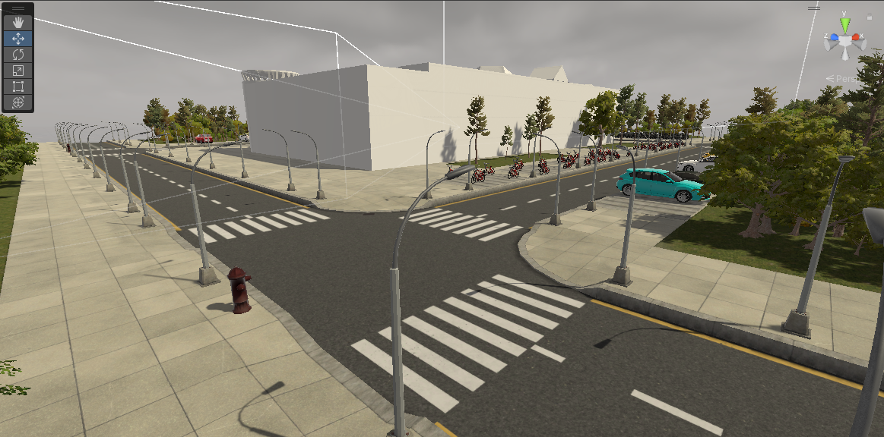

**Game Environment Picture #4**

1. Designing of the Character and Pigeons

The third person avatar that I used was a prefab from the Starter Assets. It included the design of the character (like a robot) with movement animations. All I had to do was make the Main camera a CinemacineBrain that is attached behind the avatar. Therefore, moving the avatar will cause the camera to move with it

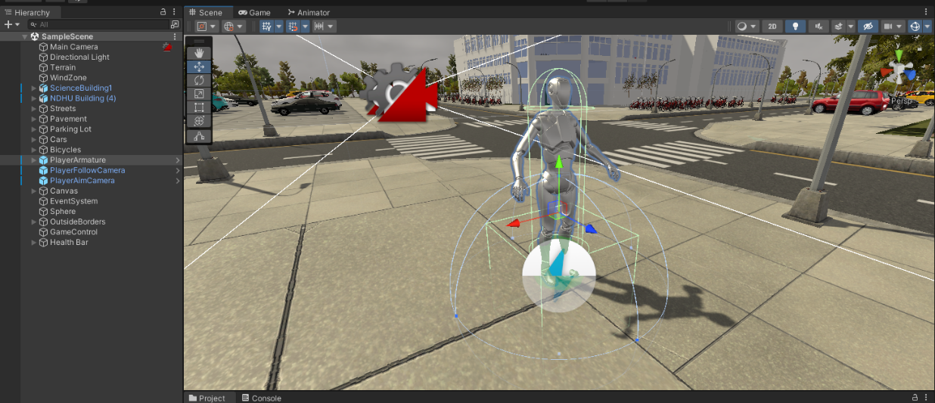

**Avatar Design Picture #1**

The design for the bird was the same as the third person avatar. The only difference is that the bird already has an included object used to detect where it will attack on the ground. As shown below in the image, the prefab was used.

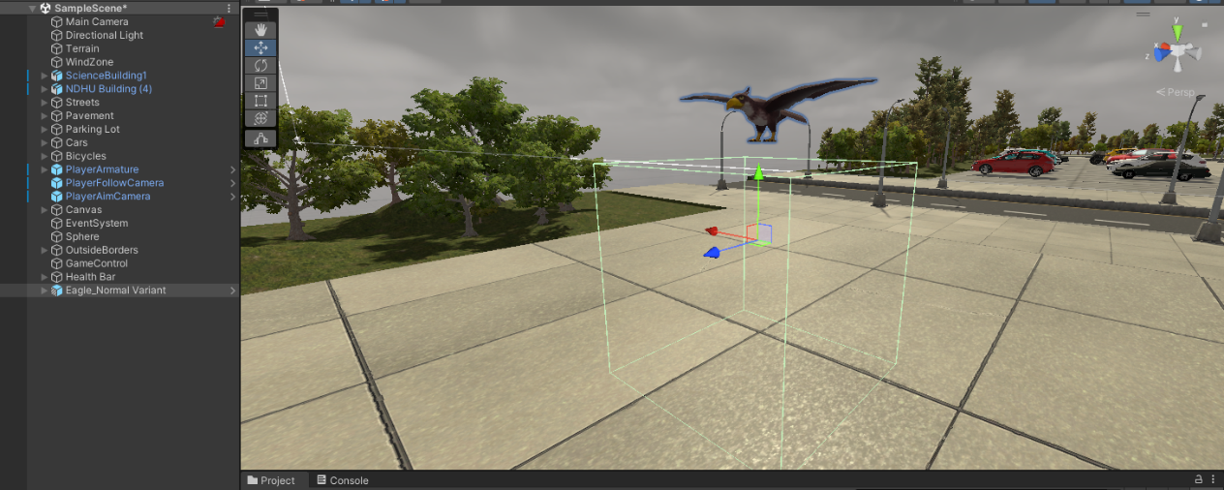

**Bird Design Picture #1**

1. Functionality of the characters and pigeons

In the above method section, I wanted to create multiple characters with multiple weapons. Initially, all of that would have been imported from assets as prefabs as I don’t have the time to individually design each weapon. Therefore, I decided to stick to one robot avatar with a shooting weapon and one type of bird.

For the character settings shown below, I attached multiple components each with their own function. “Third Person Controller” is a script that came with the character already that controlled all the movements and states. “Third Person Shooter Controller” is the script that I made to incorporate the main attack mode of the character: shooting.

Firstly, I had to set up the aim camera which is activated by using the right click on the mouse. This is used so that the character can aim before shooting. All I had to do was make another camera called “PlayerAimCamera” that was a bit zoomed in to give the illusion that the character was aiming. To aim properly, I needed to get the current mouse position and activate it when right click was pressed.

Secondly, I had to let the character shoot bullets. I designed a Bullet Prefab and Instantiated it every time a player shoots by right clicking.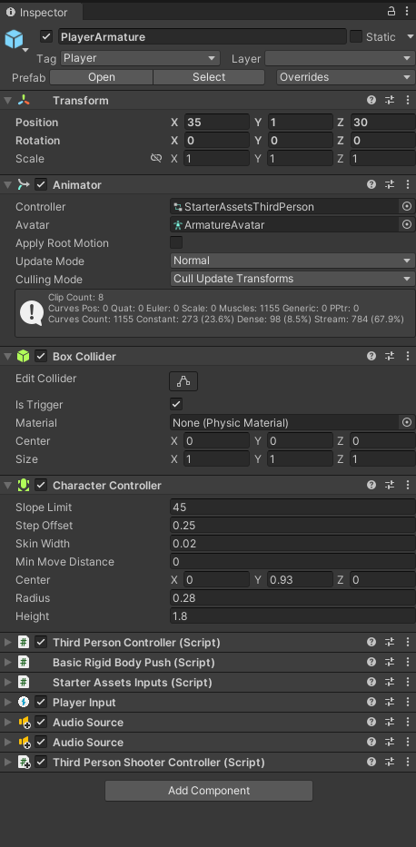 If it hits the bird, it will destroy the bird’s box collider that it encounters and release a green particle system to show users that it hit a correct target. I play a sound that I made myself as the assets did not include a shooting sound.

I also needed to include a “Box Collider” with the “isTrigger” selected in order to tell if a bird is attacking the character. The convenient function “OnTriggerEnter” first checks to see if the collider is a bird and then decreases the health and activates the hit sound if it is. There was no included hit sound or hit animation to indicate that the player was hit. Therefore, I recorded my own sounds and made a health bar to indicate to the player that the character was hit.

For the bird settings, the “deal damage component” is a script that came with the prefab and the “Bird_controller” is the script I made. Within it, I needed to make sure the bird faces and always chases the player until it is killed. I need to change the bird’s animations from “Flying” to “Attacking” when it reaches the player. Therefore, I edited the animations and made changes in my script to do this.

There was also a “death” animation for the bird that I used when it is encountered with a bullet. As previously stated, the box collider would be destroyed if the player hits it with a bullet. Therefore, in the “Update” function, I constantly check to see if the box collider is still available for that bird. The moment that it isn’t, I play the death animation and destroy the object.

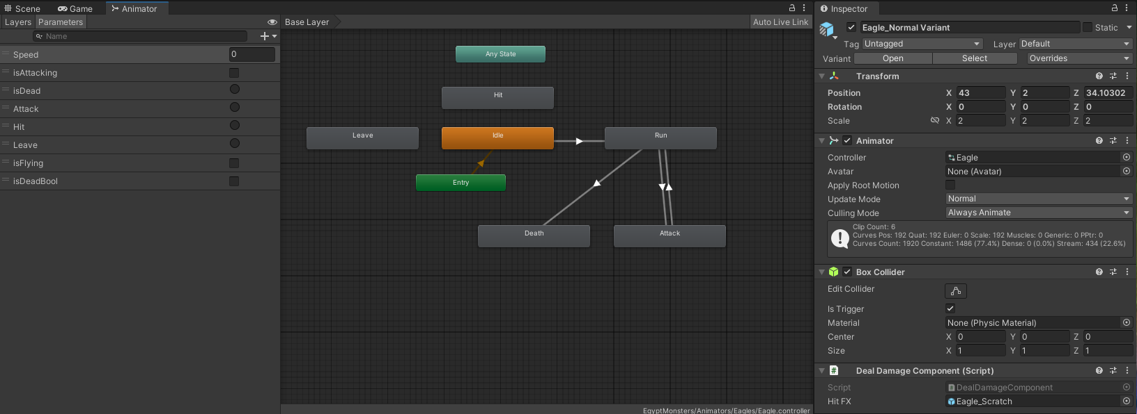

Other than these two main scripts, “Bird Generator” is a script that is used to generate a new bird every two seconds and the “Game Controller” is used to change the main states of the game incuding the death of the character and showing of the final screen.

All code and designs were done by me and can be thorughly examined in the attached unity package. However, I realized that there were some erros when exporting the package. Shown below is a screen shot of the errors I got.

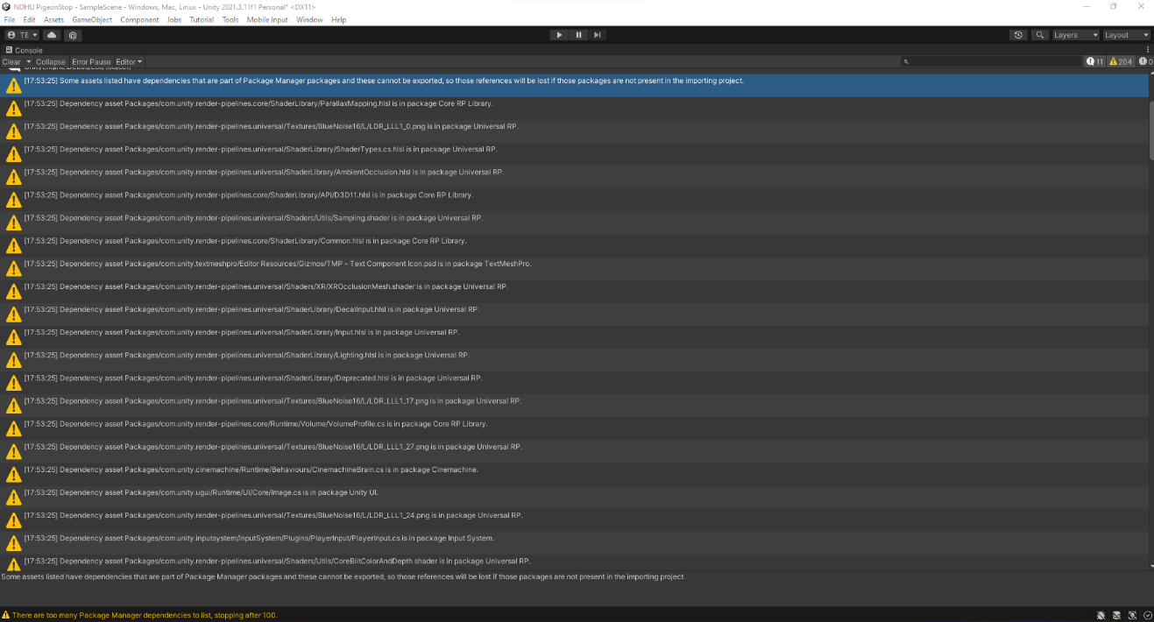

I tried to fix it but it has something to do with the unity render pipeline which I didn’t use in my project. Additionally, the bottom main message said that there are too many package manager dependencies to list, so it stops after 100. Just to be safe, I will attach both the unity package so that you can see the code I wrote and the .exe file so that you can play the game as well. I will also attach a youtube link of how the game is played.

1. Discussion

I had incorporated every thing I learnt in this class and more into my project. The dino hunter game had fascinated me but it didn’t work the way I wanted it to work. Therefore, after many hours of work, I finally made the game playable which is quite challenging. Shown below is the final screenshot of my finished project.

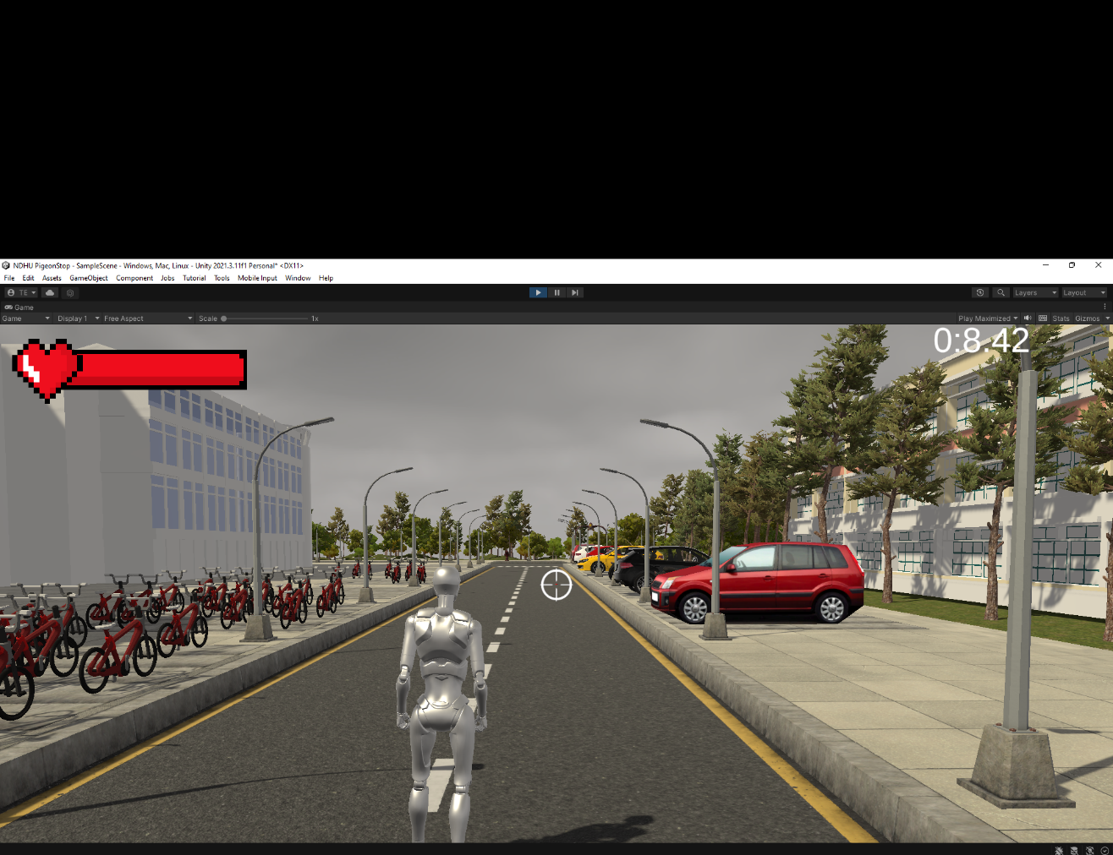

The last thing I’d like to reiterate is the restrictions I had due to limitations of free assets. I really wanted to go forth using pigeons as that is NDHU’s main bird. Moreover, I wanted to create different weapons and different characters as just one robot is a little too boring. Laslty, I also wanted to incorporate the game in VR using a VR headset, but I don’t own one. Nevertheless, I finished the project successfully and I’m proud of all my hard work.